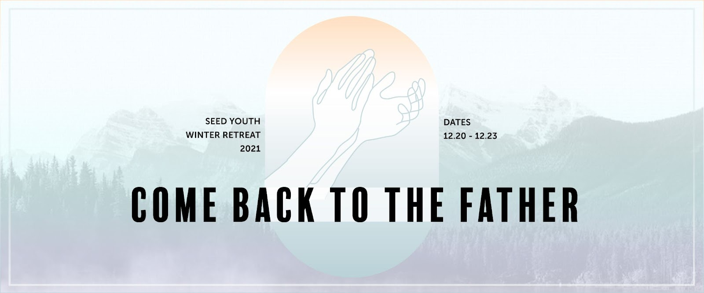

“Come Back to the Father”

2021 Seed Youth Winter Retreat

IMPORTANT INFORMATION

Departure & Arrival

- Departure: Meet at Valencia High School on 12/20 at 1pm for check in and bag
inspection. (Lunch on your own)

- Arrival: We will return to Valencia High School on 12/23 at 1pm

For Emergencies, please contact

Pastor Jason: 909-714-0551
Pastor Paul: 323-381-0901
Teacher Amie: 213-479-6600

Important Things to Know…

- Parents of all registered students will be invited to a Kakao Group Chat Room, specifically created for the winter retreat. Important announcements, updates and retreat news will be shared with the parents through this channel

- Please make sure that the students DO NOT bring any electronics or valuables. There is a high risk of students losing their belongings.
- Cell phones will be taken by our teachers and safely kept at church, so that the students can focus entirely on the retreat. We recommend that they leave the phone at home.

- COVID-19 vaccine is not mandatory. However, to ensure that everyone is safe and healthy during the retreat, we will follow CDC’s COVID-19 safety guideline. For this reason, we highly encourage those who have not yet received the vaccine to consider getting the vaccine. Please be prepared to provide your student’s vaccine status as of the retreat during the registration. All unvaccinated attendee will need to have COVID-19 testing done no more than 2 days prior to the retreat.

- Most importantly, we need your prayers! Please join our retreat spiritually by praying for the students to have deep and personal encounter with God

THINGS TO BRING

- Sleeping bag
- Pillow (optional)
- Bible
- Pen/notebook
- Clothing for 4 days (warm clothes)
- Toiletries
- Towel
- Sweater and Winter Jacket
- Tennis Shoes/Sneakers
- Slippers for shower
- Flashlight
- Watch
- Prescription medication (Please turn in during check-in)
- Reusable water bottle
- Teachable heart and Excitement!

